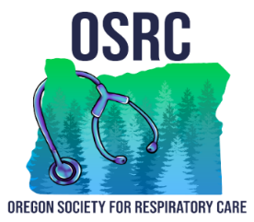

OSRC 2026 Educational Conference
RT Student Poster Presentation Details

Event Overview

During the lunch session on Day 2 of the OSRC Educational Conference, student participants will have the opportunity to present their poster boards to a panel of esteemed board members. This session promises to be an engaging showcase of innovative ideas and research findings.

Prizes

Participants have the chance to win exciting prizes based on the quality and impact of their presentations:

1st Place

Award: NBRC Testing Exam Fee paid OR
All expenses paid trip to the 2026 AARC International Congress
- Location: New Orleans, LA
- Dates: November 14-17, 2026
2nd Place

Award: $200

3rd Place:

Award: $150

Presentation Tips:

- Clarity: Ensure your poster is easy to read and understand.
- Engagement: Be prepared to explain your research and answer questions.
- Visuals: Use charts, graphs, and images to make your data more accessible.
- Practice: Rehearse your presentation to stay within the time limit and convey your points effectively.

This session is an excellent opportunity to gain recognition for your work and advance in your professional journey. Good luck to all participants!

